Material

* lemon essential oil -> 380 microL
* surfactants: we use two different surfactants (one for water and one for oil it depends on the hydrophilicitys degree)
* TWEEN 80 -> 20 microL
* PVA 1,1% colored with phenol red (pH indicator) - 0,022 mL
* Water
* Micropipettes
* UV lamp
* Metacrilated gelatin

Methods

1. Create an emulsion : first we mixed 380 microL of lemon essential oil with 20 microL of TWEEN 80, then, in a different test tube, we mixed PVA (1.1%) with water in a 2 mL solution. We obtained an oil-in-water emulsion by dropping small drops of oil in water and mixing everything well mecanically using a vortex (30s at 40hz (x3) for a stable emulsion). At the end of the process the oily phase should be dispersed in water forming fine stable droplets.
2. Build the hydrogel : We incorporate the nanoparticles obtained in the first step with a metacrilated gelatin containing LAP (0.5%) as a photoinitiator. LAP has been solved in water as 4% of the total volume and then incorporated in the gelatin.

For the design of the right hydrogel we tested out 3 different concentrations of our compound in gelatin for a total volume of 300 microL.

| Trial | Oil-in-water emulsion (μL) | Gelatin (μL) | Total volume (μL) |
| --- | --- | --- | --- |
| A | 150 | 150 | 300 |
| B | 100 | 200 | 300 |
| C | 50 | 250 | 300 |

1. Casting and gelification : the gelification of our compound occurred by Photopolymerization. Photopolymerisation or photocrosslinking begins with the photoinitiator, LAP in this case, which is cleaved to form free radicals that initiate a polymerisation reaction that forms cross-links between the methacrylate residues. 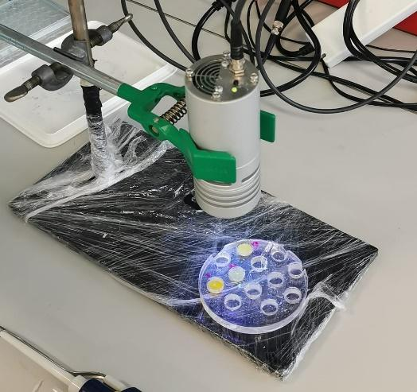

The LAP photoinitiator, in addition to initiating the reaction, also serves to refine the photocrosslinking experiment (i.e. altering hydrogel stiffness or gelling speeds).

The 3 different mixtures A, B and C were first placed in small round containers and then photocrosslinked by leaving them under UV light for 1 minute.

1. Nanoparticles release and H2O resistance:

After gelling, we assessed whether the properties of the three discs could be compared to those of a hydrogel. We tested their behavior in water by focusing on their solubility rate and stiffness and it turned out that only compounds B and C had the properties of a hydrogel, i.e. those compounds with a higher percentage of gelatin.

The trial number one, A, on the opposite, does not possess the properties of a hydrogel because of its low gelatin content.

In fact the mechanical properties of the hydrogel are given by the network bonds that are created in the gelatin after the photopolymerization treatment due to its composition, therefore, the stiffness and porosity of the material depends mainly on the percentage of methacrylated gelatin.

We chose C as our hydrogel (1/6 nanoparticles – 5/6 gelatin).

*Figura 2 “C” had all the properties of a hydrogel, the right rigidity and a reduced disintegration rate in water, resulting in greater stability and, in terms of application, in a slow and controlled release of nanoparticles. B is also a hydrogel but with a higher release rate while A lacks the properties of a hydrogel due to its low gelatin content.*

1. Injectable hydrogel:

In conclusion we tested whether our hydrogel was injectable.

In order to do this, we recreated the "C" pre-hydrogel solution, as shown in the table, and placed it into a syringe at room temperature. Then we put the syringe in a freezer at 4 ° C for 10 minutes until we get a high-viscosity compound.

This type of technique is called physical cross-linking, in fact it uses temperature to compact the gelatin creating new cross-links that make the compound rigid. This reaction is reversible until blocked with a chemical-crosslinking.

Fortunately the hydrogel we chose was injectable and retained its shape after chemical crosslinking.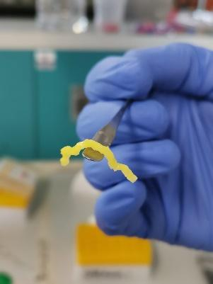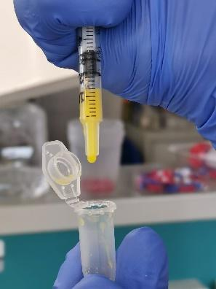

In conclusion we succeeded in creating a methacrylated gelatin hydrogel able to release lemon essential oil based nanoparticles in the environment.

On the other hand, lemon-essential-oil based nanoparticles are affordable, easy to prepare and retain LEO known for its neuroprotective and anti-microbial properties.

1. (<https://www.sigmaaldrich.com/IT/it/product/mm/cc3242>)
2. (Soltanzadeh M, Peighambardoust SH, Ghanbarzadeh B, Mohammadi M, Lorenzo JM. Chitosan nanoparticles encapsulating lemongrass (Cymbopogon commutatus) essential oil: Physicochemical, structural, antimicrobial and in-vitro release properties. Int J Biol Macromol. 2021 Dec 1;192:1084-1097. doi: 10.1016/j.ijbiomac.2021.10.070. Epub 2021 Oct 19. PMID: 34673101.)
3. .Eddin LB, Jha NK, Meeran MFN, Kesari KK, Beiram R, Ojha S. Neuroprotective Potential of Limonene and Limonene Containing Natural Products. Molecules. 2021 Jul 27;26(15):4535. doi: 10.3390/molecules26154535. PMID: 34361686; PMCID: PMC8348102.